Welcome to Term 1 2020
with Mrs Aroozoo!
Welcome!
This term the year ones begin their new journey into studying and speaking in a new language, Japanese!
They will begin the year with great songs and fantabulous games that allow the students to practice writing and reading their name and speaking simple greetings and give them time to develop their Japanese accent!
In year 2-3 we are consolidating our learning and spending part of our learning time practicing reading and writing the first alphabet- Hiragana!
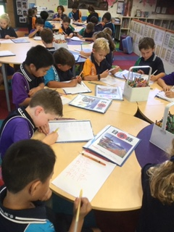
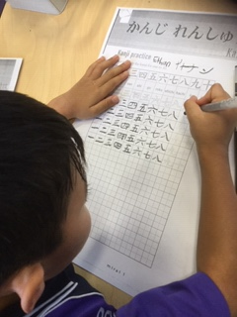
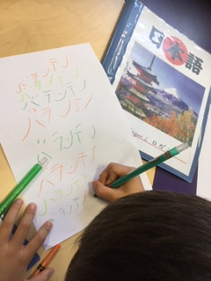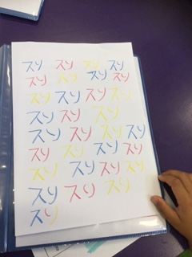
Once again, I will add the Hiragana chart to this post so students can take the opportunity to study at home!
Revision of topics such as school and greetings will be part of the plan, as well as learning more interesting ways to express their feelings.

Years 4-6 will once again be consolidating their Hiragana with tests in week 7 & 8 with an expectation of them achieving fluency by the end of term 1. This will give them confidence when they begin the next alphabet Katakana!

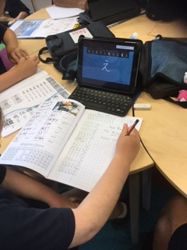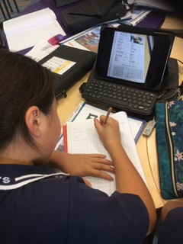

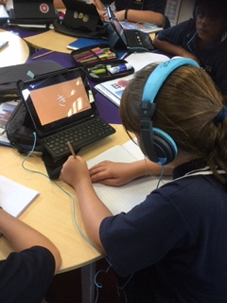

Anticipate seeing them videoing themselves for their portfolios showing you their progress!

I look forward to a wonderful term of learning progress with all our St Emilie’s students!
Below is a Hiragana chart for your children to download and practice at home!

